**Date:30-07-2024**

**Day_11_Linux_Assignments:**

**1.Problem Statement: Inter-Process Communication (IPC) using Pipes, Shared Memory, and Message Queue.Design and implement efficient and reliable inter-process communication (IPC) mechanisms using pipes, shared memory, and message queues in C to facilitate data exchange and synchronization between multiple processes within a single system.Specific Requirements:Pipe: Create and manage unidirectional and bidirectional pipes for simple data transfer between related processes.Shared Memory: Allocate and manage shared memory segments for efficient data sharing between multiple processes.Message Queues: Create and utilize message queues for asynchronous communication and data exchange with message prioritization.Synchronization: Implement appropriate synchronization mechanisms (e.g., semaphores, mutexes) to coordinate access to shared resources and prevent race conditions.Error Handling: Incorporate robust error handling to manage potential IPC failures and resource leaks.**

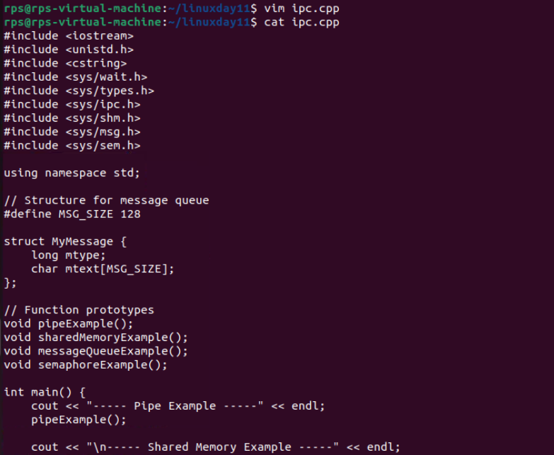

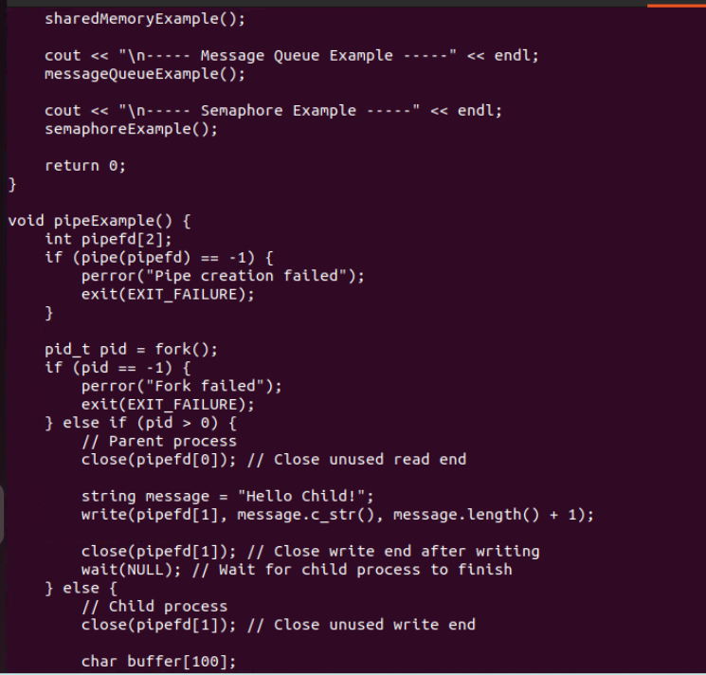

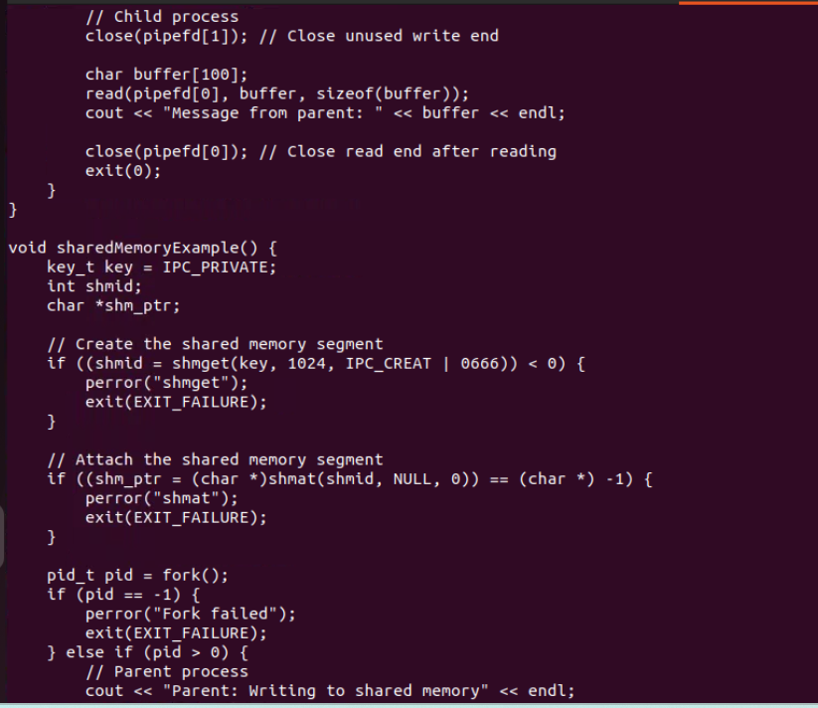

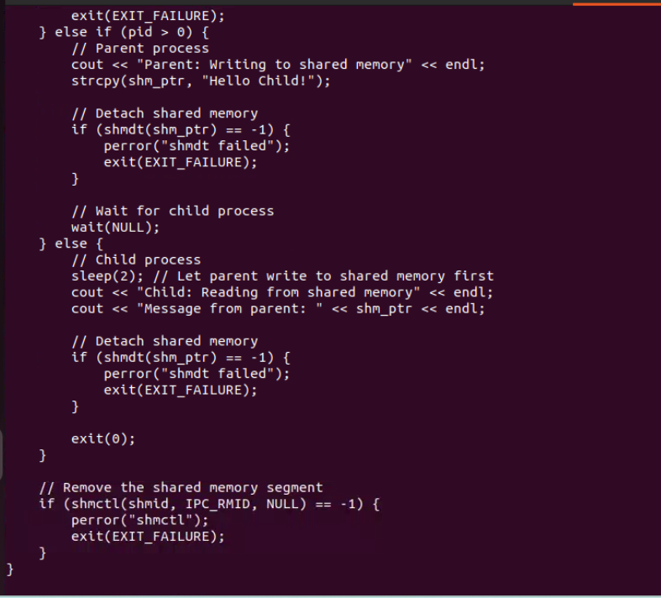

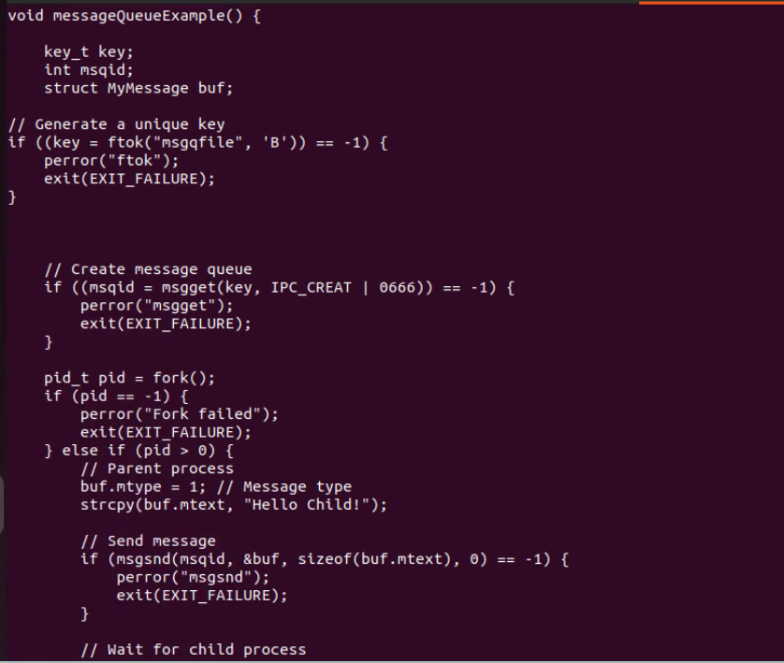

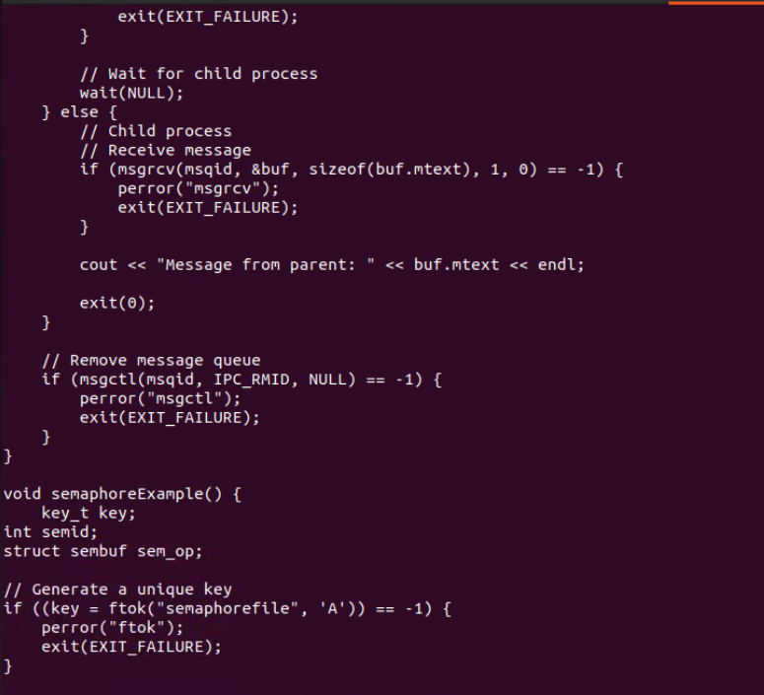

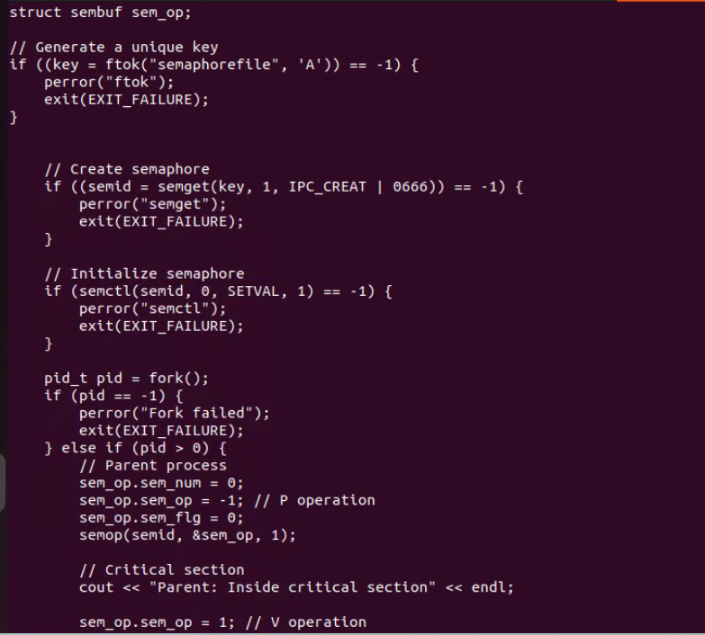

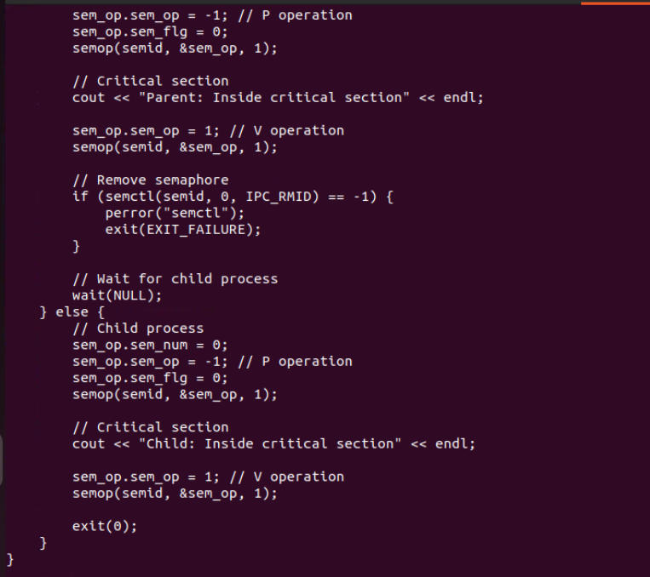

**Output:**

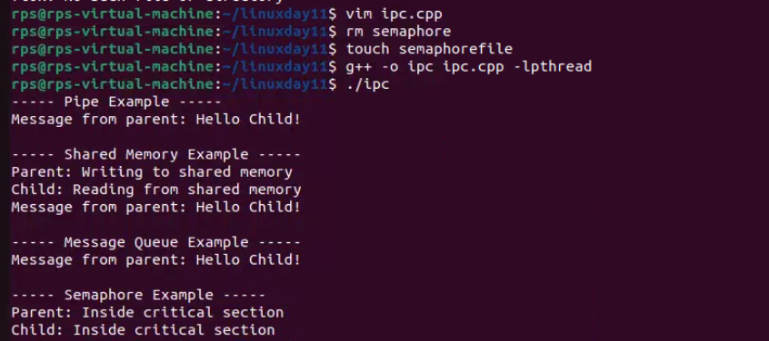

**2.** **Signal Handling:Write a C++ program that sets up a signal handler for SIGINT. The program should perform some tasks and print a message when SIGINT is caught, then terminate gracefully.How would you modify your program to handle multiple different signals, each with a unique handling function?**

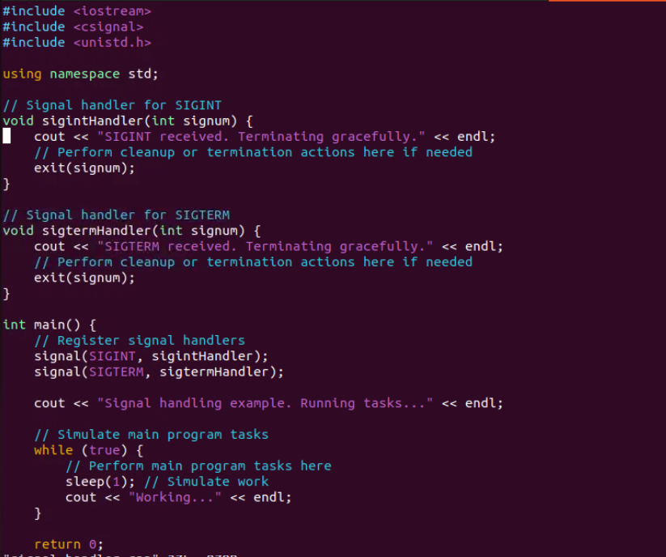

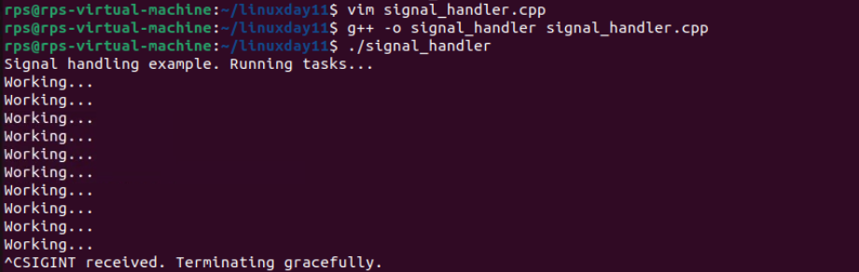

**3.** **Sockets for Network Communication:Implement a simple echo server in C++ that listens on a specific port, accepts client connections, and echoes back any messages received from clients.Write a client program that connects to the echo server, sends a message, and prints the echoed response.**

**Server code:**

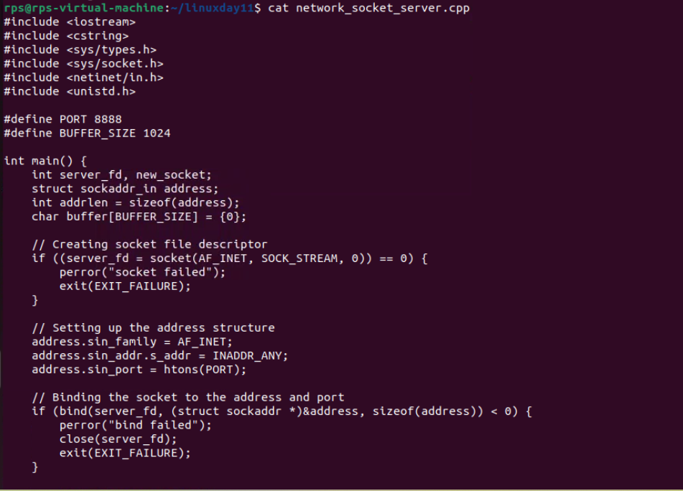

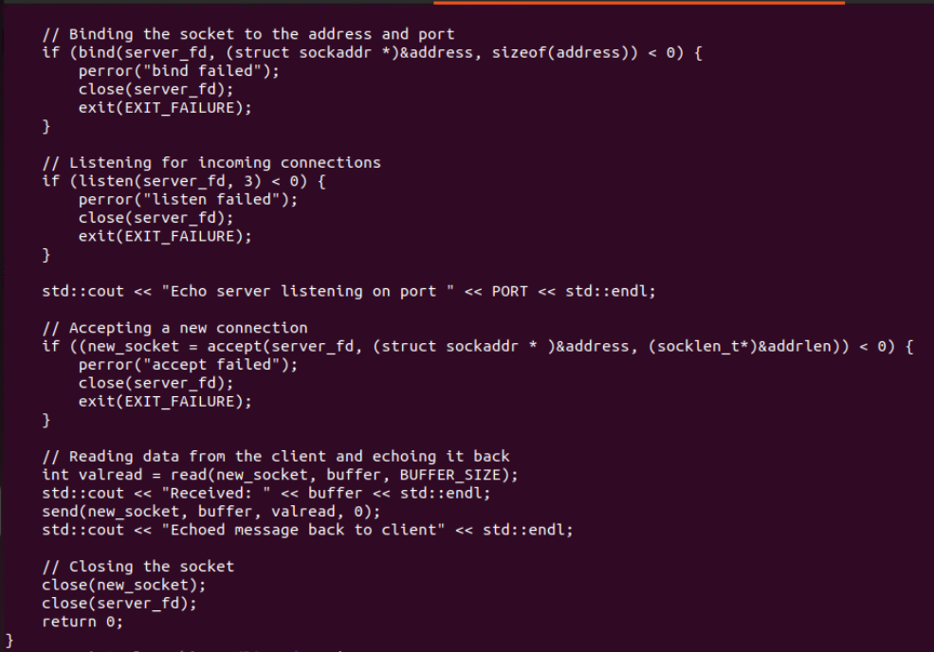

**Server output:**



**Client code:**

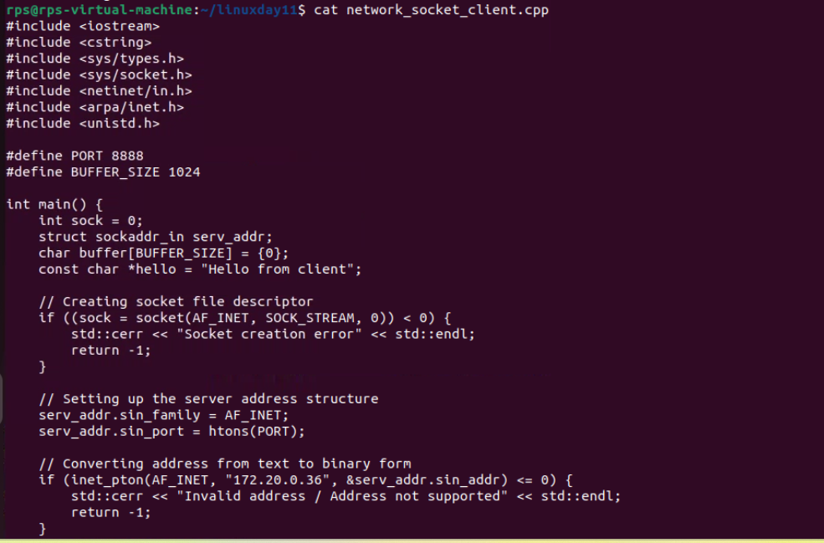

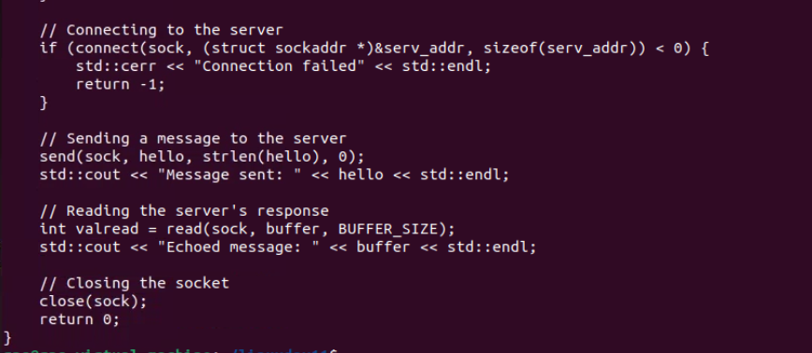

**Output:**



**4.** **Inter-Process Communication (IPC): Write a C++ program that creates a parent process and a child process. Use a pipe for IPC to send a message from the parent to the child, and have the child process print the message.How would you modify the program to use a message queue instead of a pipe for communication between the parent and child processes?**

**Using Message Queue:**

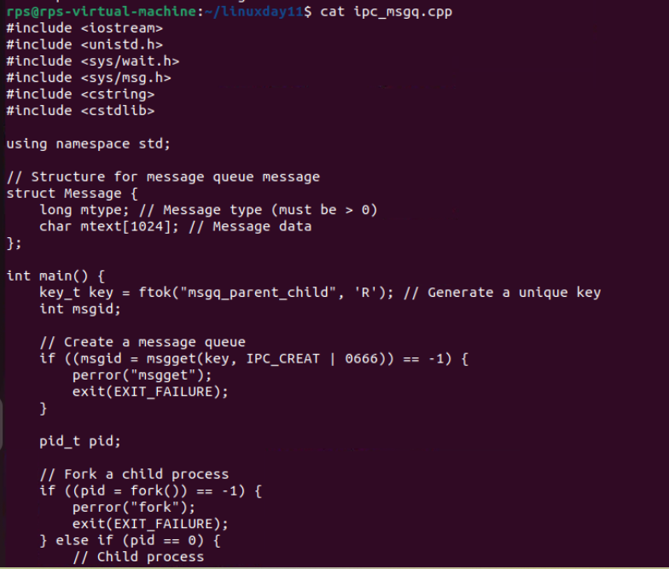

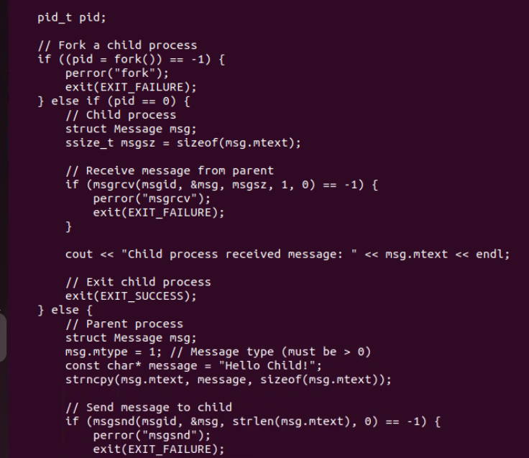

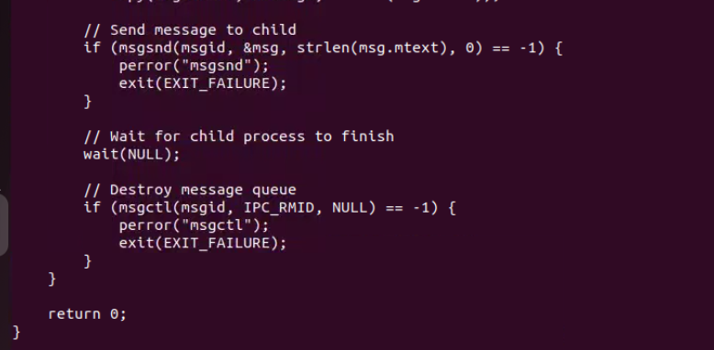

**Output:**



**Using pipe:**

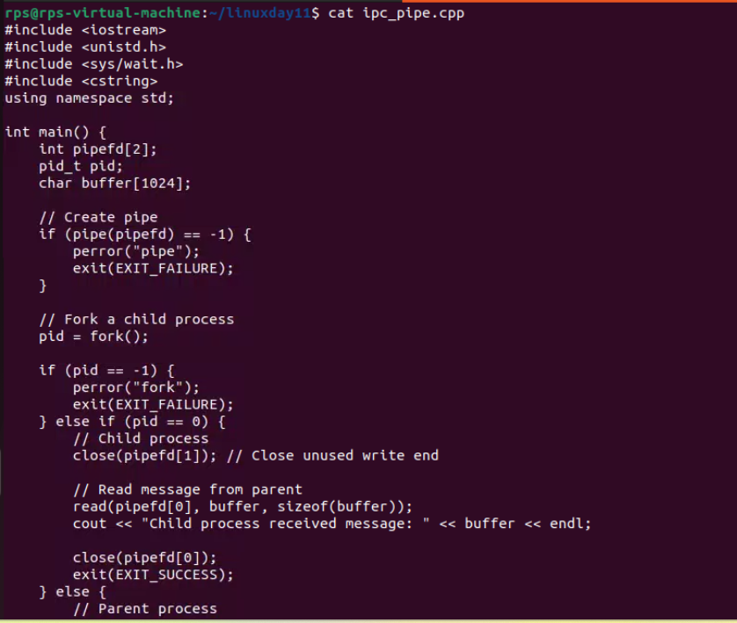

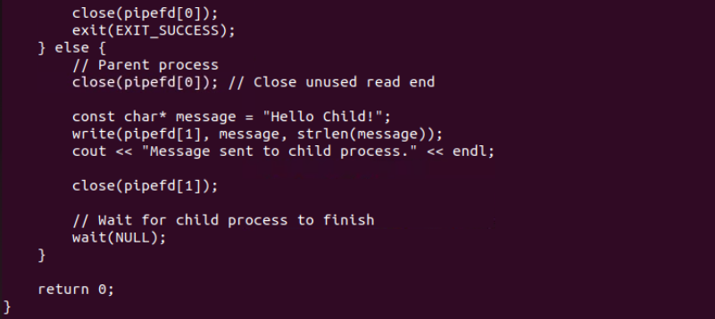

**Output:**

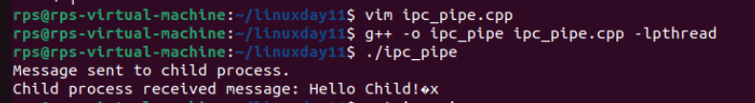

**5.** **Design and implement a robust, distributed system using C++ that effectively leverages signals, sockets, and inter-process communication (IPC) to manage and coordinate multiple processes for a real-time data processing pipeline.System RequirementsData Ingestion: Continuously receive data from multiple sources (e.g., network sockets, files, sensors) and distribute it across multiple worker processes.Data Processing: Distribute incoming data to multiple worker processes, each responsible for specific data transformations or calculations.Error Handling: Implement robust error handling mechanisms using signals to gracefully handle unexpected events (e.g., process termination, network failures).Inter-Process Communication: Utilize IPC (e.g., shared memory, message queues) for efficient communication and synchronization between processes.Performance Optimization: Optimize the system for low latency and high throughput, considering factors like network congestion, process scheduling, and data transfer efficiency.Scalability: Design the system to handle increasing data volumes and processing load by dynamically adjusting the number of worker processes.**

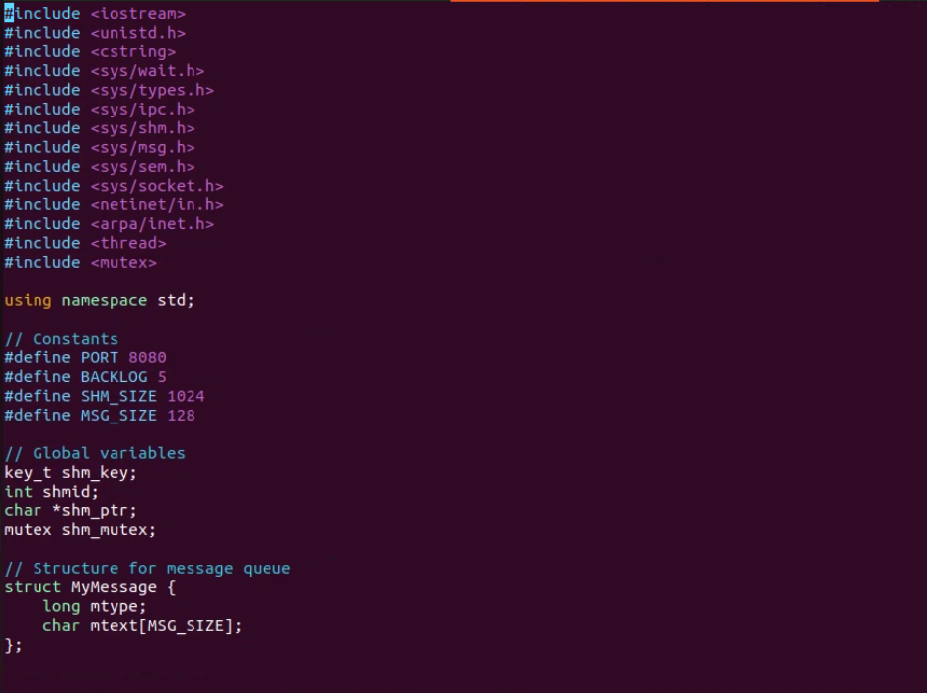

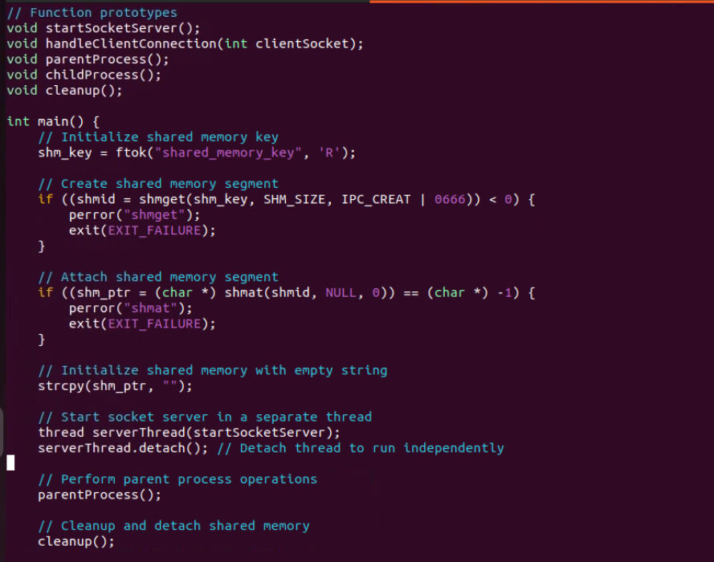

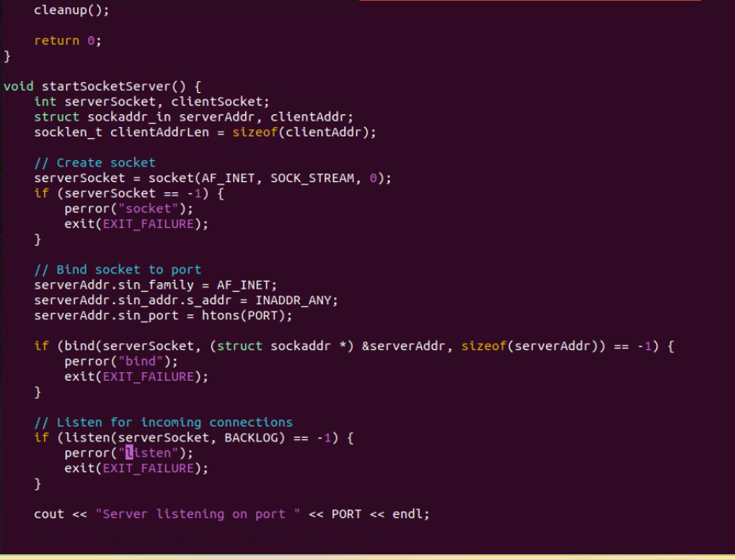

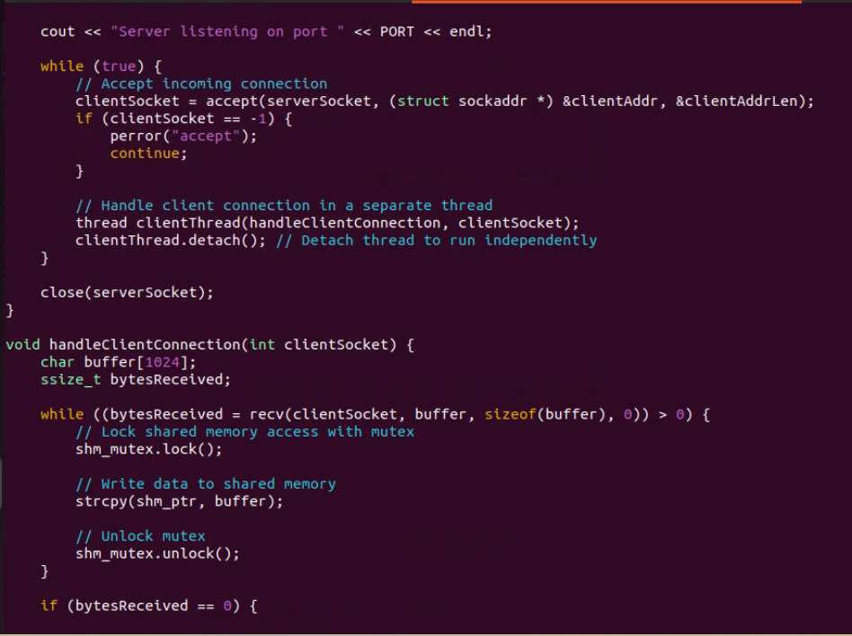

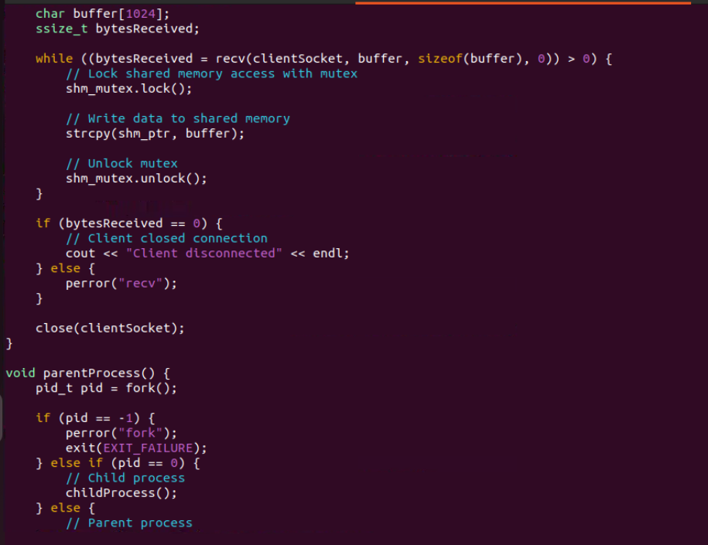

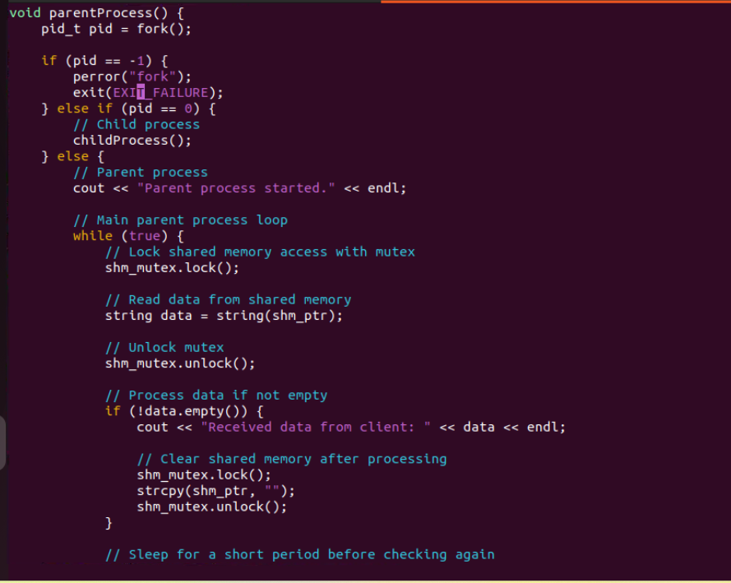

**Output:**

